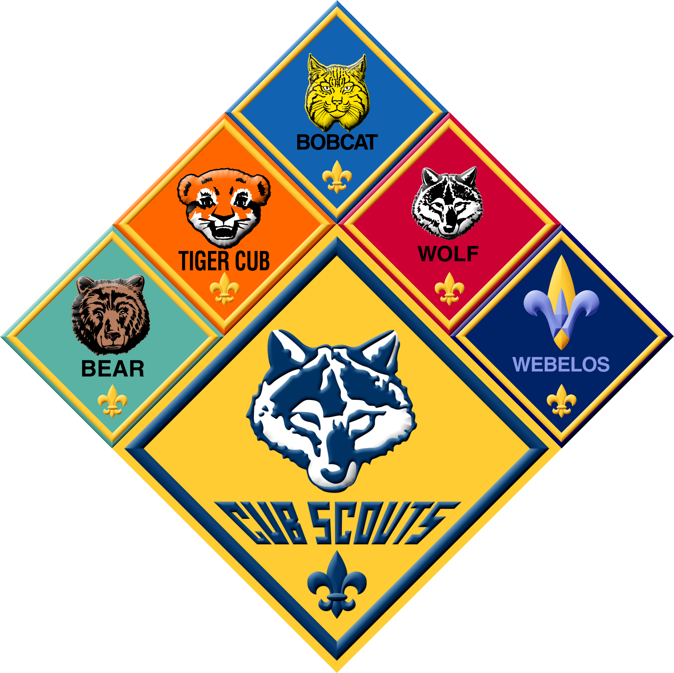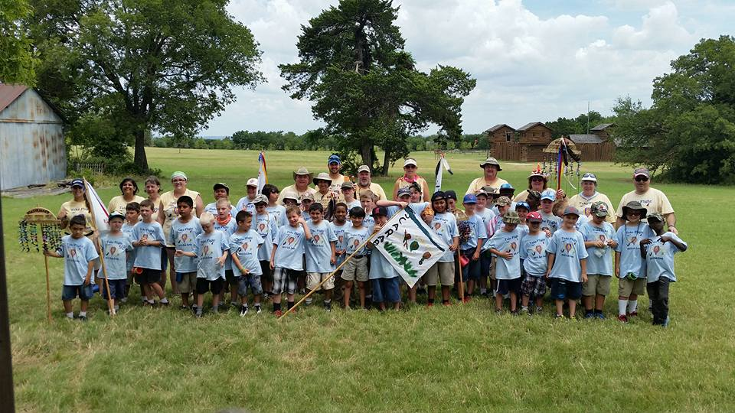

## Summer Fun Dates

Dust off your pickle bucket and clip on your water cup, **June 20th-24th**, is Day Camp at Camp Wisdom. Meet at FUMC parking lot at **7:30a** every morning to carpool. You MUST be on time with your pickle bucket and lunch!

1. Pickle Bucket/Homer Bucket with lid
2. Sunscreen
3. Bug Spray
4. Hat
5. Swimsuit
6. Towel
7. Carabineer
8. Small plastic cup with handle
9. Change of clothes with socks
10. Rain poncho, just in case
11. Money for Trading Post ($1-$2 per day suggested)
12. Lunch in small cooler every day
13. Wear camp shirt
14. Wear shorts with belt loops
15. Wear tennis shoes and socks
16. Smile!

# Day Camp List

www.pack771irving.org

Facebook: Cub Scout Pack 771

Twitter: @pack771

8/20

Ice Cream Social, FUMC 6p

Night Hike 8p at River Legacy Park

8/6

Water Fun Day, FUMC, 10am

7/16

7/4

7/9

Cedar Ridge Hike, 9am

Fourth of July Parade, 8:45am, meet on Second St., wear uniform

Flag Ceremony FUMC at 6:15p, wear uniform

7/3

6/20-24

DAY CAMP! Meet at FUMC at 7:30a with pickle bucket & lunch, see list to right

Fishing Derby 8a, Towne Lake Park, bring your fishing poles for the chance to win prizes

6/18

Hike at Dogwood Canyon, 9am

6/11

Pack 771 Irving

May 2016

Five Trails District

Circle 10 Council