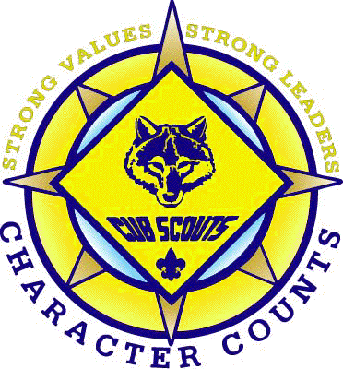 | September 2015 Circle 10 Council, Five Trails  Pack 771

Cub Scout Pack 771  First United Methodist Church 211 W. 3rd St.  Irving, TX 75060  www.pack771irving.org  Facebook: Cub Scout Pack 771 Twitter: @pack771    It’s time for POPCORN!!! This is our biggest fundraiser! Popcorn sales are how we cover our budget costs for the year. What a great way for scouts to build character, work on communication skills, and earn their own way in scouting! Let’s have 100% participation from our scouts and have everyone try to reach the sales goal of $400 per scout! | 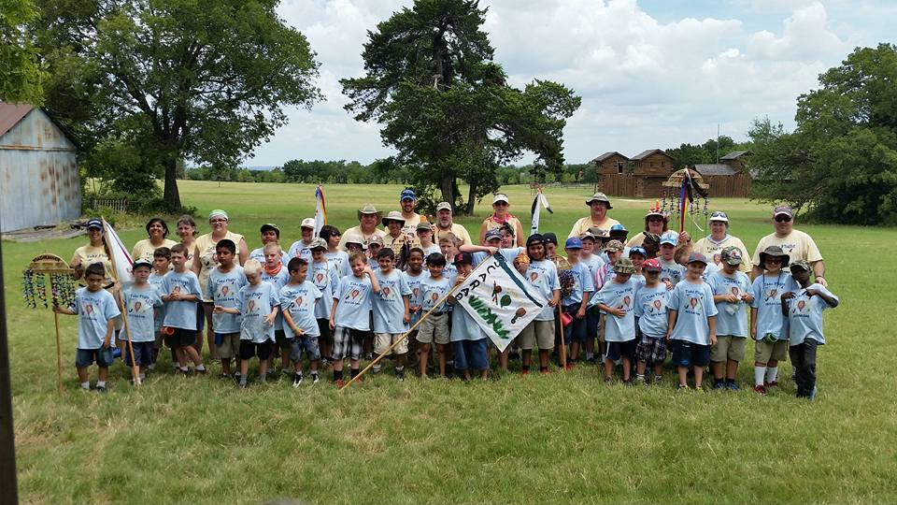  Pack 771 having fun at Day Camp!  Upcoming Activities  10/11 Church Cleanup – FUMC at 4:00pm  Come help clean the sanctuary as we say thank you to FUMC for their support.  10/13 Game Night 6:30pm – FUMC  Bring a game to play, deadline for popcorn orders, t-shirt orders, campout sign-up  10/16-10/18 Fall Camp Out – Trevor Rees-Jones Scout Camp –  11217 FM 2970, Athens, TX 75751  Price is $7pp and includes your campsite, Sat. breakfast and dinner and Sunday breakfast. Deadline to signup and pay is 10/13 at Game night.  10/26 Pack Meeting 7pm FUMC

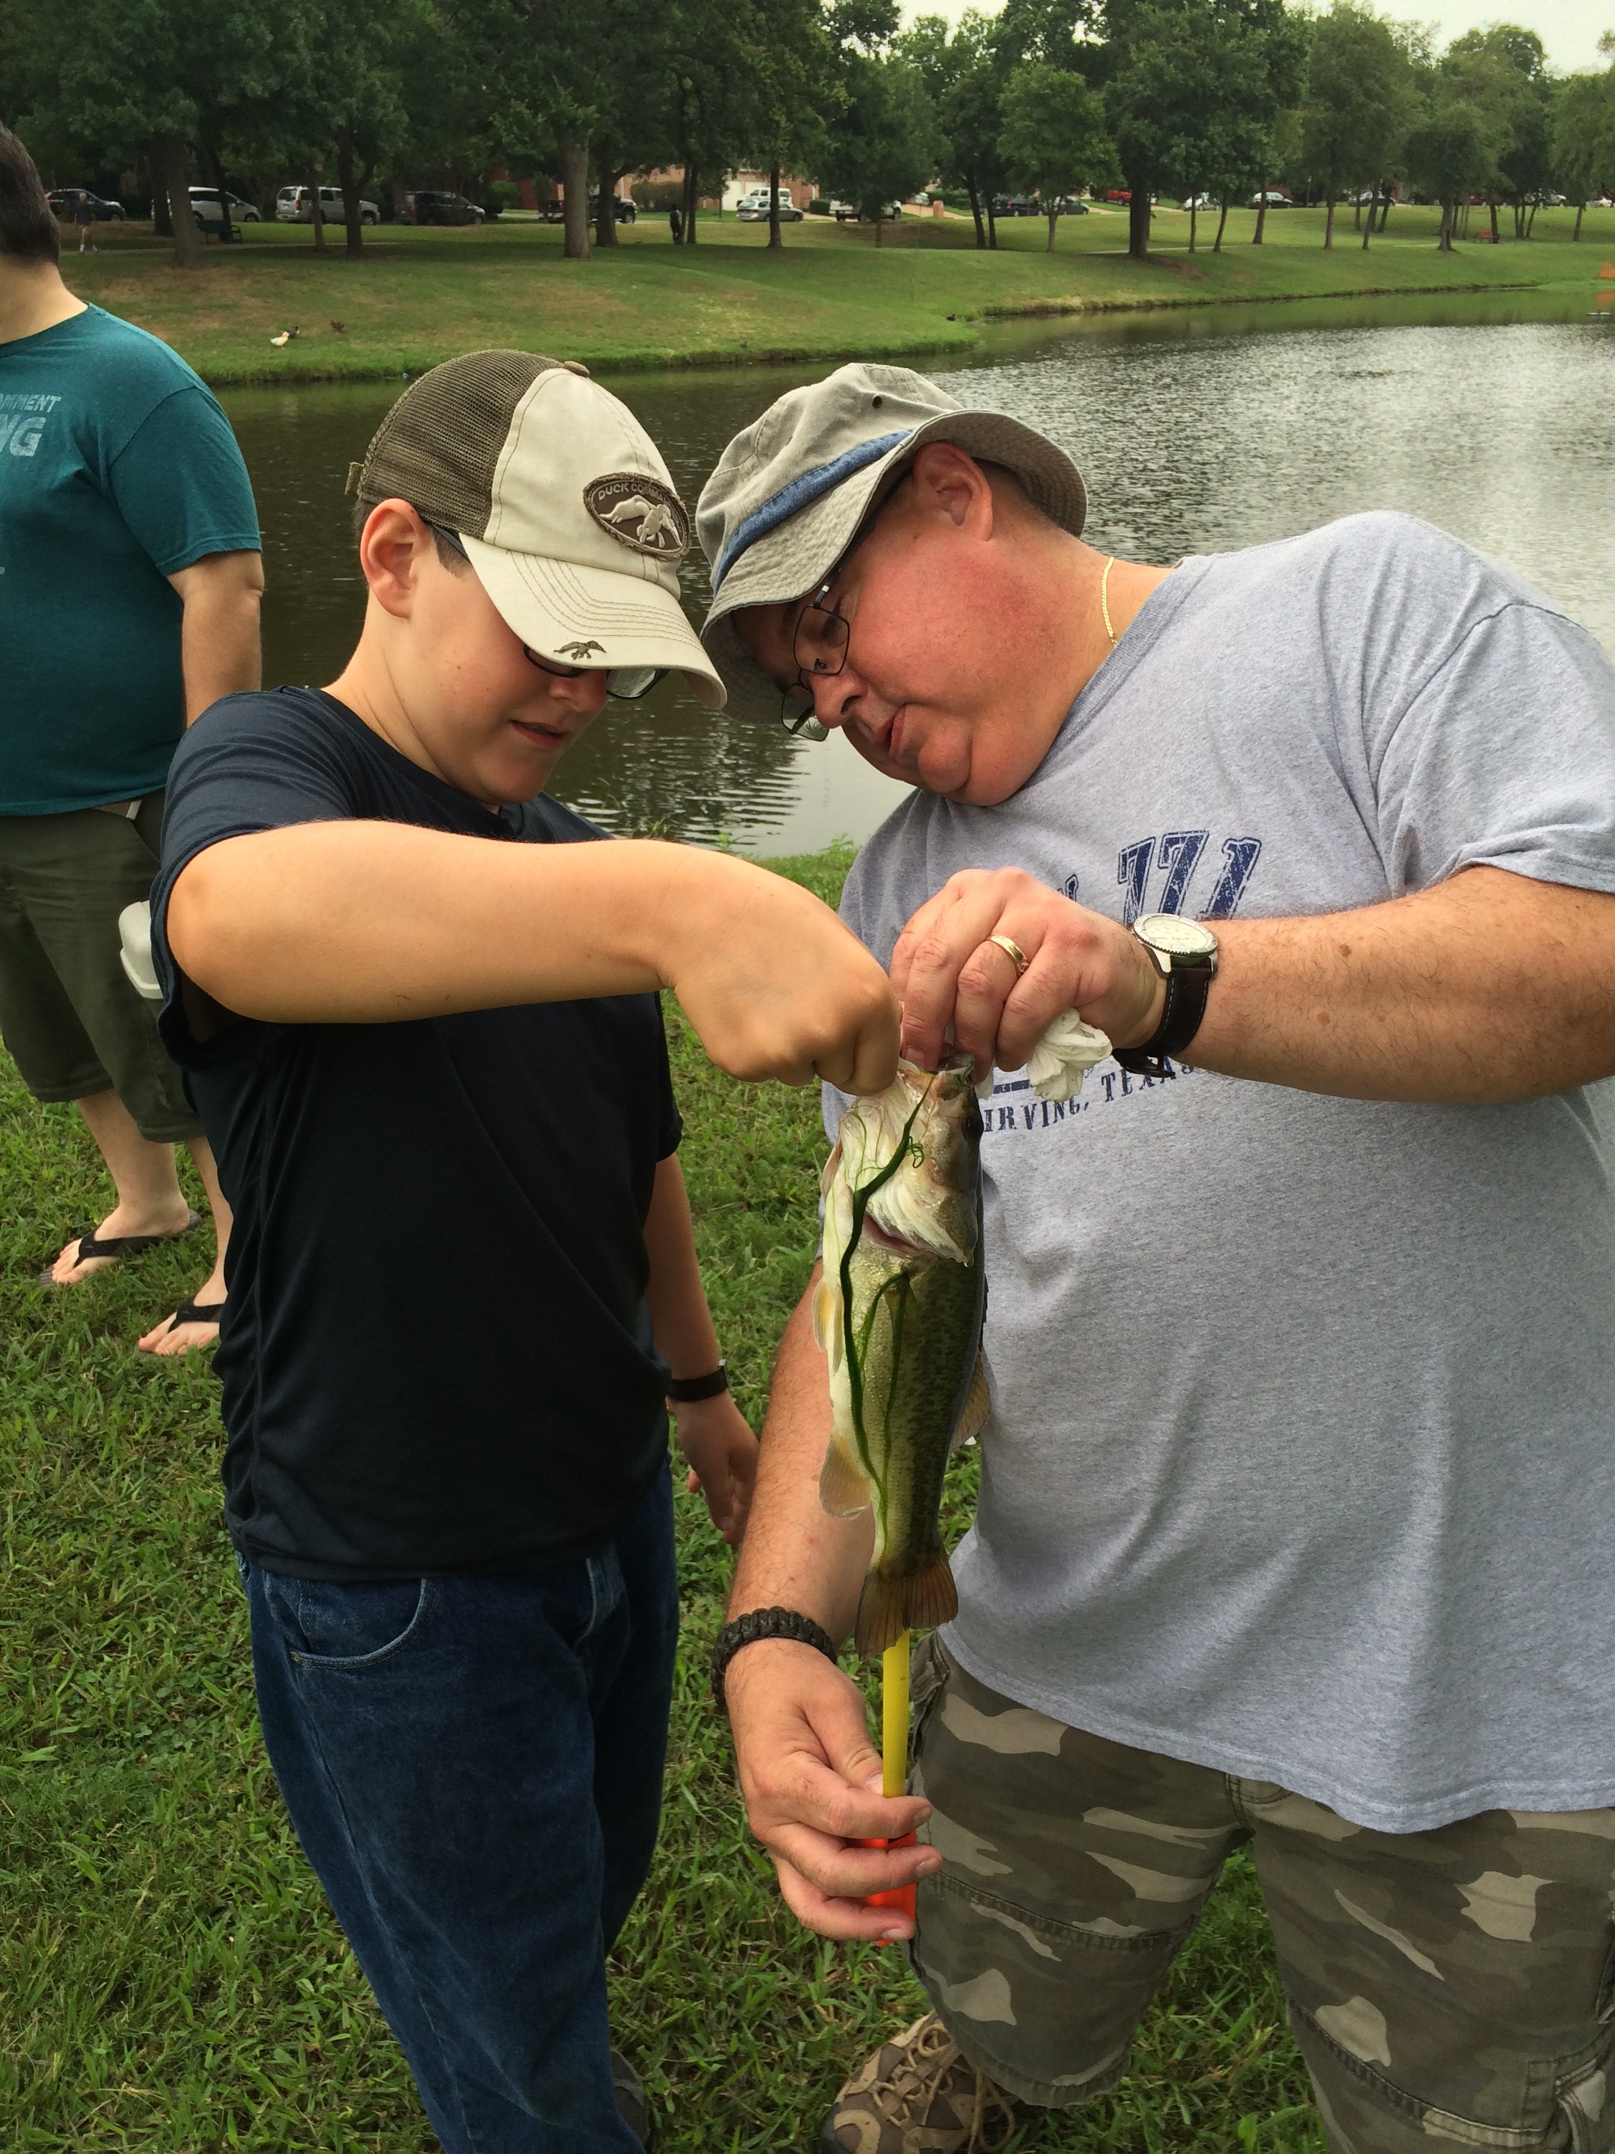  Hunter’s big catch at summer fishing derby  Den Assignments for October Pack Meeting  Entrance Table Pirates  Set Up Den 3  Opening Den 6  Cheers Alien Patrol  Skit Phoenix Patrol  Closing Den 1  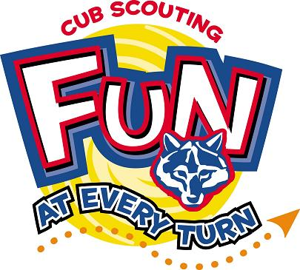  Cubby Corner  Why couldn’t the pony speak?  It was a little hoarse.  What lies on the bottom of the ocean and twitches?  A nervous wreck.   Friend us on Facebook!  www.facebook.com  Cub Scout Pack 771 | Fall Campout 10/16-10/18 Trevor Rees-Jones Scout Camp  11217 FM 2970  Athens, TX 75751  The fall campout will be Friday 10/16 to Sunday 10/18 at Trevor Rees-Jones Scout Camp in Athens.  We will start Friday setting up our tents, visiting and maybe make smores. Saturday morning will start with breakfast together then an outdoor flag ceremony. Saturday’s activities include a hike, fishing and other activities. We will have a chili frito pie dinner and finish off with Dutch oven cobbler, followed by some fun skits, and silly jokes. Sunday morning we will have a grab and go breakfast, Scout Service and closing flag ceremony.  Cost is $7 per person. Since we are staying at a scout camp the cost of the campsite is free. Your charge includes breakfast Saturday, dinner Saturday and breakfast Sunday. You are responsible for your food for Friday night and Saturday lunch and extra snacks and drinks.  Deadline to pay is October 13th.  If you need camping gear or have any questions about the campout please email Karissa Rife at kk_jones84@yahoo.com.  Camping Checklist:  Tent / tent stakes/ tarp for under tent  Tent broom  Sleeping bags  Air mattress/ cot  Pillows/ blankets  Bug repellent/ sunscreen  Lantern/ extra batteries  Flashlight  Lawn chairs  Extension cord  Camp stove/ fuel  Pot/ pan  Firewood for campfire/lighter/fuel  Water bottle/reusable plate/fork/ mess kit/ coffee mug  Hammer  First aid kit  Camera (for scavenger hunt too)  Dish soap/ rag/ brillo pad  Garbage bag  Paper towels/ napkins  Can Opener/ hot pad/ cooking utensils/ roasters  Ice chest/ drinks/ snacks/ coffee/ condiments  Food for Fri. dinner, Sat. breakfast and lunch  Freeze gallon water for ice chest then drink when melted  Rain gear  Towel/ washcloth/ toiletries for shower/ shower shoes  Hats  Extra socks/ jacket  Scooter/ bicycle  Small backpack to wear during hike  Optional: fun lights to decorate campsite |   Important Popcorn Dates  Popcorn Orders Due 10/13 Location: Game Night at FUMC at 6:30pm  Popcorn Pick-Up 11/7 Location: FUMC 9a-11p  Popcorn Money Due 11/16 Location: FUMC Pack Meeting  Spring Campout Fun!  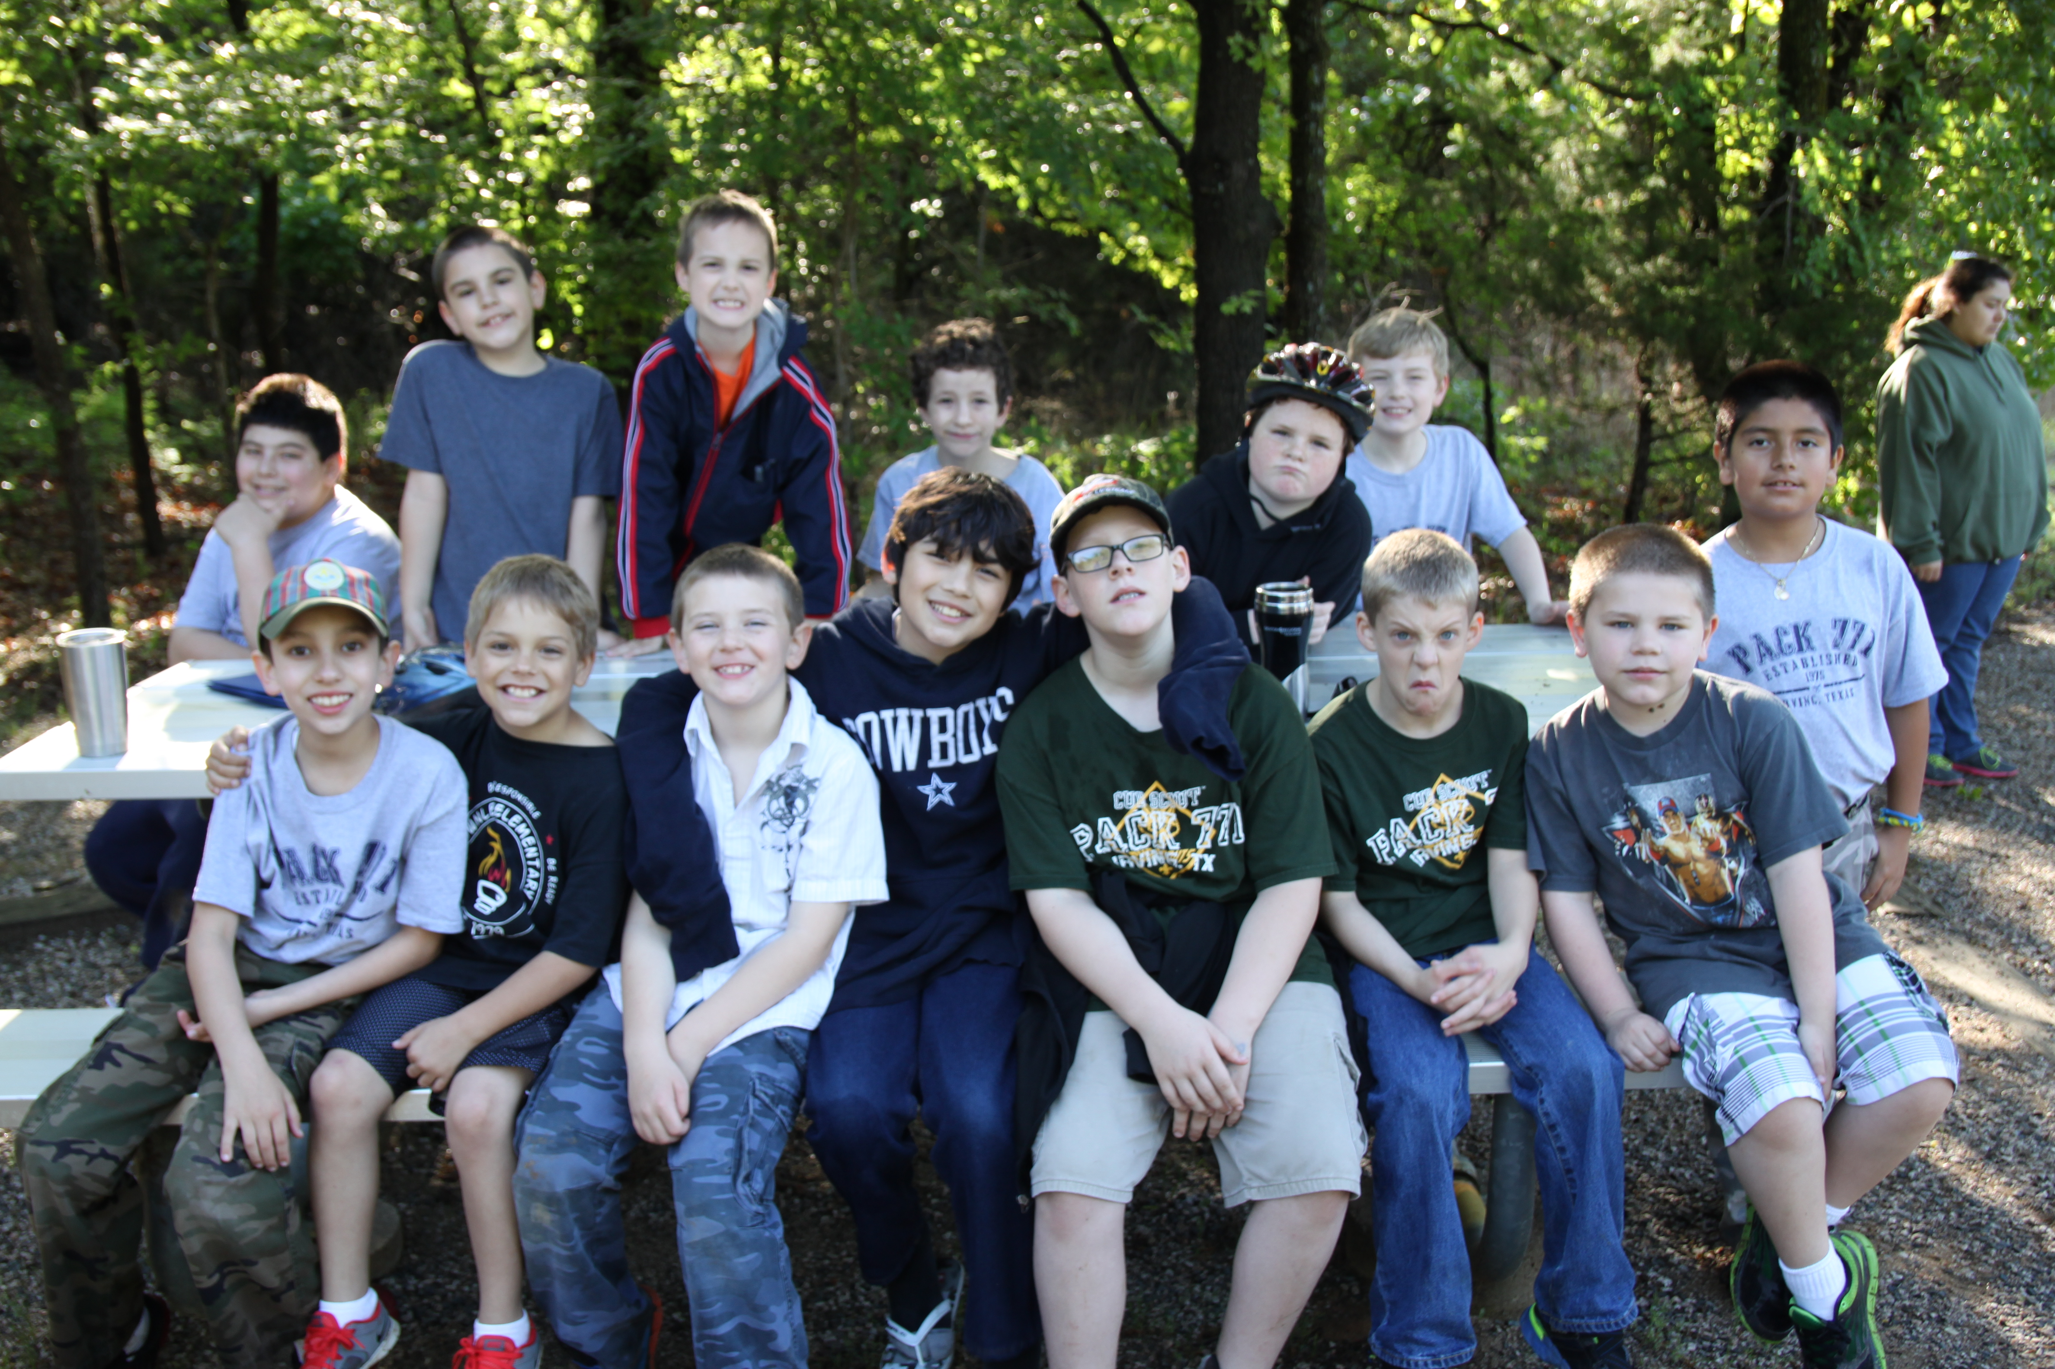  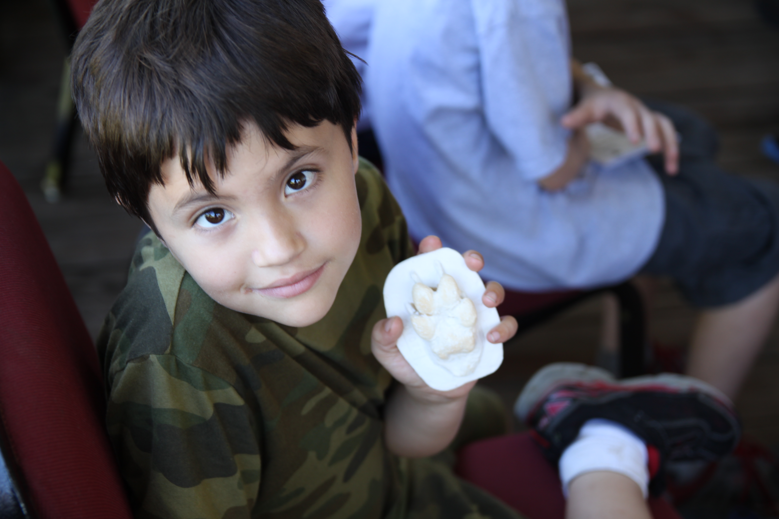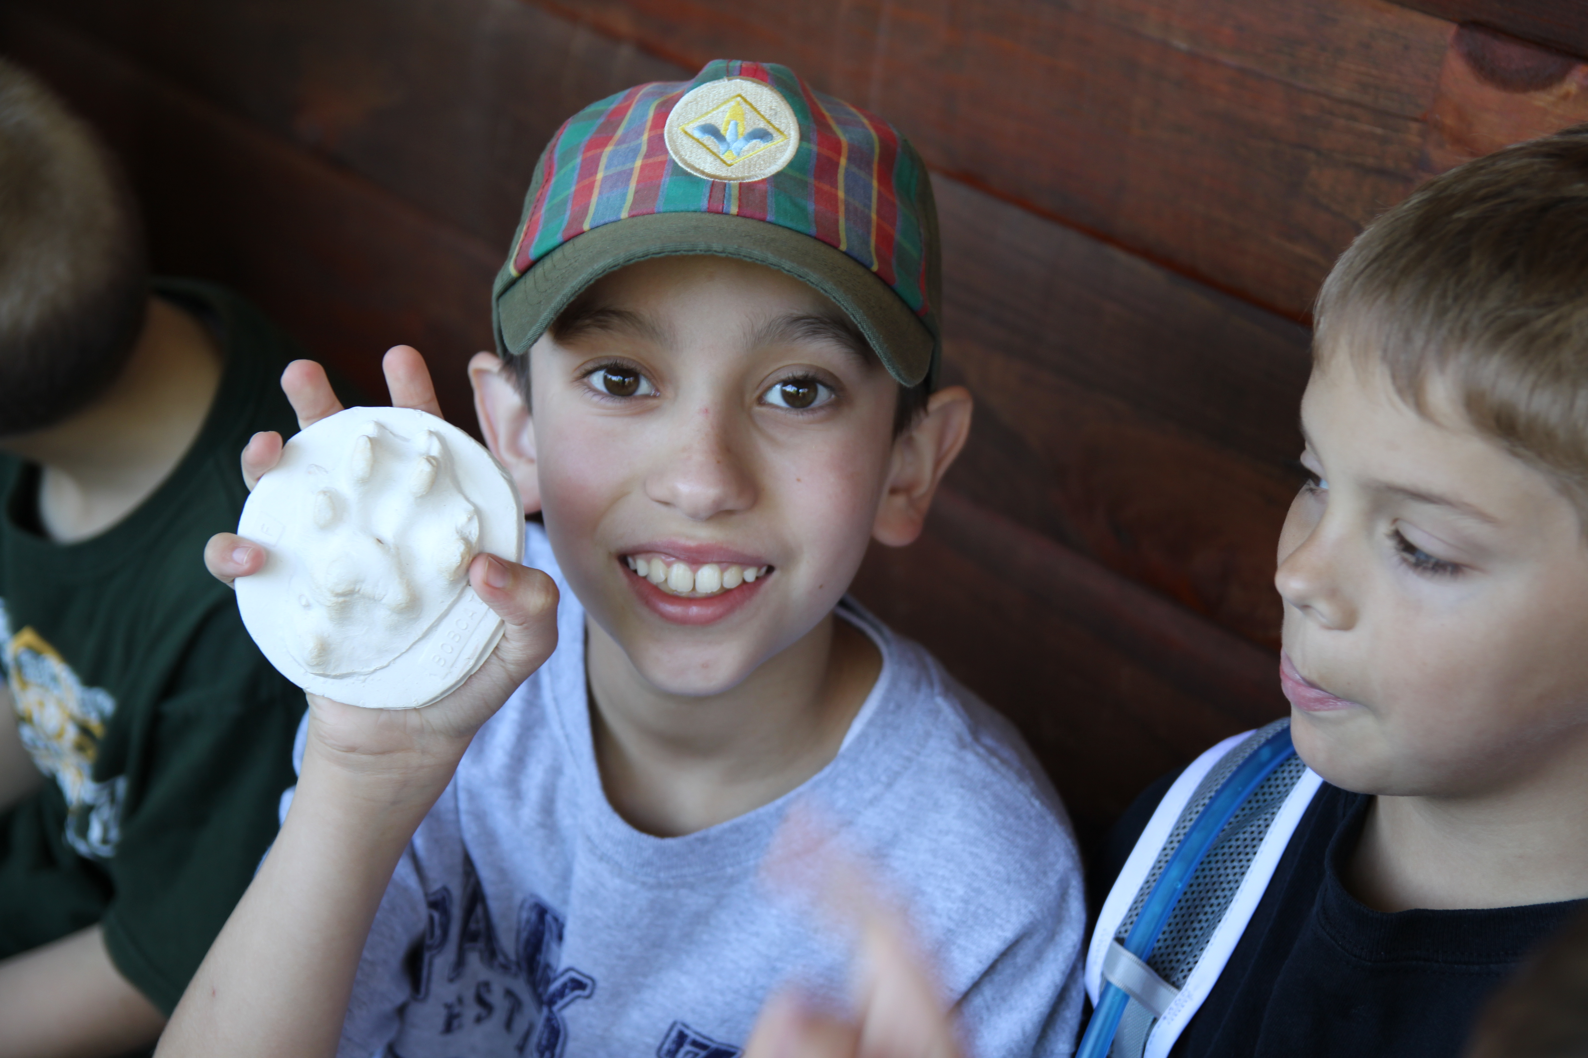  Jorge Matthew  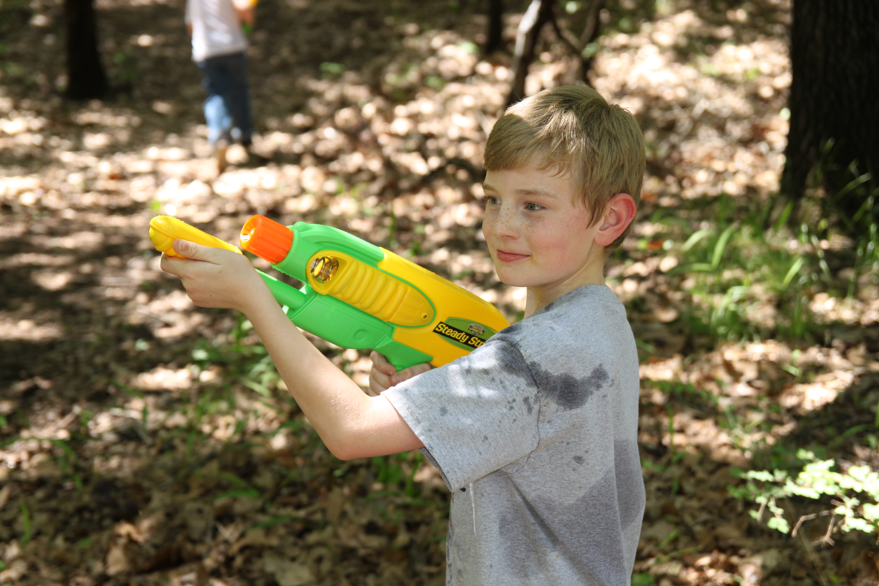  Billy

