 | September 2013 Circle 10 Council, Five Trails  Pack 771

Cub Scout Pack 771 First United Methodist Church 211 W. 3rd St. Irving, TX 75060  www.pack771irving.org FB: Cub Scout Pack 771 Twitter: @pack771    It’s time for POPCORN!!! This is our biggest fundraiser! Popcorn sales are how we cover our budget costs for the year. What a great way for scouts to build character, work on communication skills, and earn their own way in scouting! Let’s have 100% participation from our scouts and have everyone try to reach the sales goal of $400 per scout! | 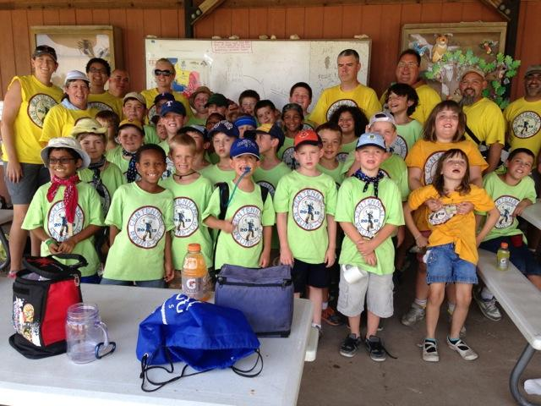  Pack 771 having fun at Day Camp!  Upcoming Activities  9/28 Trinity Trash Bash Location: T.W. Richardson Grove Park Time: 9 am - 12 pm Wear a pack t-shirt if you have one 10/19 Jamboree on the Air Location: National Scouting Museum Time: 10:00 am - 5:00 pm Wear a pack t-shirt or your uniform  9/28 Pack Hike Location: Campion Trails Mountain Creek Preserve Time: 2pm Cost: free Wear a pack t-shirt if you have one 10/25 - 10/27 Fall Family Campout Location: Mineral Wells State Park Cost: $25 per family $5 per person for food Money is due by 10/18  10/13 Church Clean-Up Location: FUMC Time: 4:00 pm Wear a pack t-shirt if you have one 10/28 October Pack Meeting Location: FUMC Time: 7:00 pm Wear your Halloween costume Carnival games following meeting

Den Assignments for October Pack Meeting  Set Up Den 8  Opening Den 2  Cheers Den 4  Skit Rattlesnake Patrol  Closing Den 7  September Pack Hike 9/28  2:00 pm  Campion Trails at Mountain Creek Preserve, 9/28. Located at the corner of Hunter Ferrell and Nursery.  This is a good hike to start with at 4 miles on a paved, flat trail. Plus, we will stop for a break on an old abandoned bridge that was once used by American outlaws Bonnie and Clyde.  Please bring water, sunscreen, a hat, and a snack. We will meet in the far East parking lot. Wear your pack t-shirt if you have one.  S. Nursery Rd, Irving,  TX 75060  Cubby Corner  What do you call a bird that cleans its nest?  A feather duster.  Why didn’t the sun go to college?  It already had a million degrees. | Fall Campout 10/25-10/27 Lake Mineral Wells State Park  100 Park Road 71  Mineral Wells, TX 76067  The fall campout will be Friday 10/25 to Sunday 10/27 at Lake Mineral Wells State Park.  We will start Friday evening joining the park for their Night Sounds program. Saturday morning will start with an outdoor flag ceremony. Saturday’s activities including a hike, some beltloop workshops, and a craft. We will have a cookout dinner and finish off with Dutch oven cobbler, followed by some fun skits, and silly jokes. We will end the day joining the park on their Spider Walk. Sunday morning we will have a Scout Service and closing flag ceremony.  Cost is $25 for the campsite and $5 per person for food. A family of 4 will cost $45.  There is a $7 daily entrance fee at the park for everyone 13 and older.  If you need camping gear or have any questions about the campout please see Bret Bolton or Kevin Chapman.  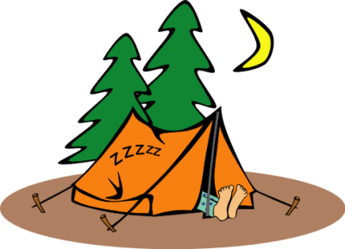 | Important Popcorn Dates  Popcorn Orders Due 10/23 Location: The Bolton House 1533 Fireside Way  Popcorn Pick-Up 11/16 Location: FUMC  Popcorn Money Due 12/4 Location: The Bolton House 1533 Fireside Way    Trinity Trash Bash 9/28  9:00 am - noon  T.W. Richardson Grove Park 333. E IH 635, Irving TX  Join us for a park clean up. Hot dogs & chips will be served @ 11:00.  Located at the NE corner of the intersection of Highway 161 and I-635  The easiest way to get to the park from the south: take Riverside Drive north to LaVillita. Take a right at LaVillita, and as soon as you go under the highway (635), the park is right there.  Wear your pack t-shirt if you have one

